**Cloud-based Sign Language Recognition App Project**

**Team ID: B21-CAP0436**

**Selected theme: Competitive Human Resource  
Mentor: Johanes Glenn** (mentoring done on 21 May 2021)

**Member : 1. Nafarel Triyoga Maskuncoro (Android)**

**2. Hezkiel Rivaldo Siregar (Android)**

**3. Nur Ardli Rachmat Saputra (Cloud)**

**4. Darell Adham Kumara Damaraji (Cloud)**

**5. Lie Reynaldo Ivander Gunawan (Machine Learning)**

**6. Andi Josua Simanullang (Machine Learning)**

#### **Backgrounder:**

Based on data from the Ministry of Health's Pusdatin in 2019, of all persons with disabilities, 7.03% were deaf and 2.57% were speech impaired. In everyday life, they use sign language to communicate, but there are still many people who do not understand sign language so that it is difficult for them and the community to communicate with each other in daily life and at work. Our group wants to raise this issue to facilitate communication between the two parties.

Based on these problems there are several research questions that we have collected:

1. How many types of sign languages are often used in Indonesia?
2. What makes it difficult for people with those disabilities to get a job?

* Machine Learning: Using layered convolutional neural networks to recognize hand sign language based on the input image pixels data.
* Android: Implementing CameraX for capturing image and making a connection to push captured image to firebase storage and pulling the result from firestore database.
* Cloud: Integrating Android app and Machine Learning in Cloud. Machine learning deployed as serverless machine learning using Cloud Function triggered by Cloud Storage and then forward the result of machine learning model to Cloud FIrestore.

#### 

#### **Screenshots**

Firestore Database:

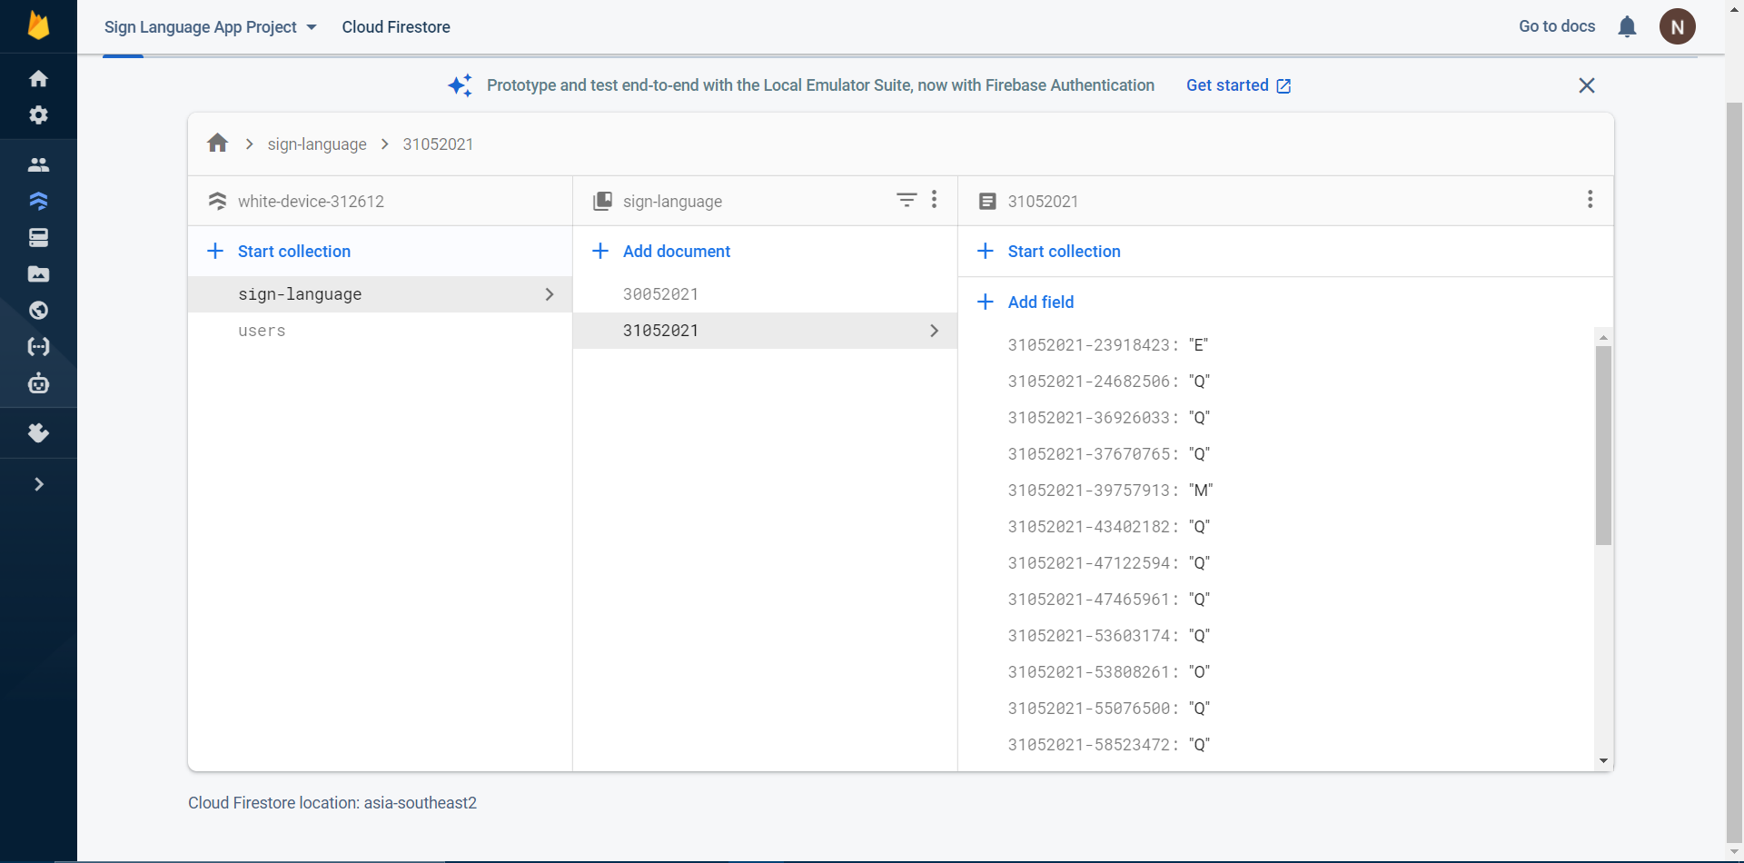

Android Application:

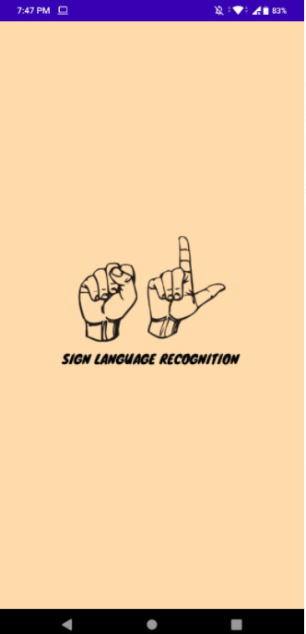 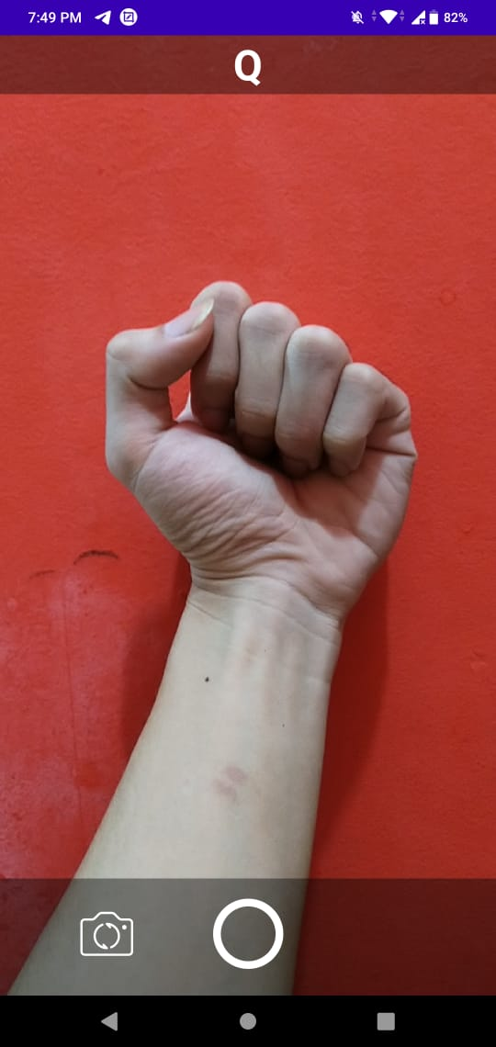

Machine Learning Sequential Model

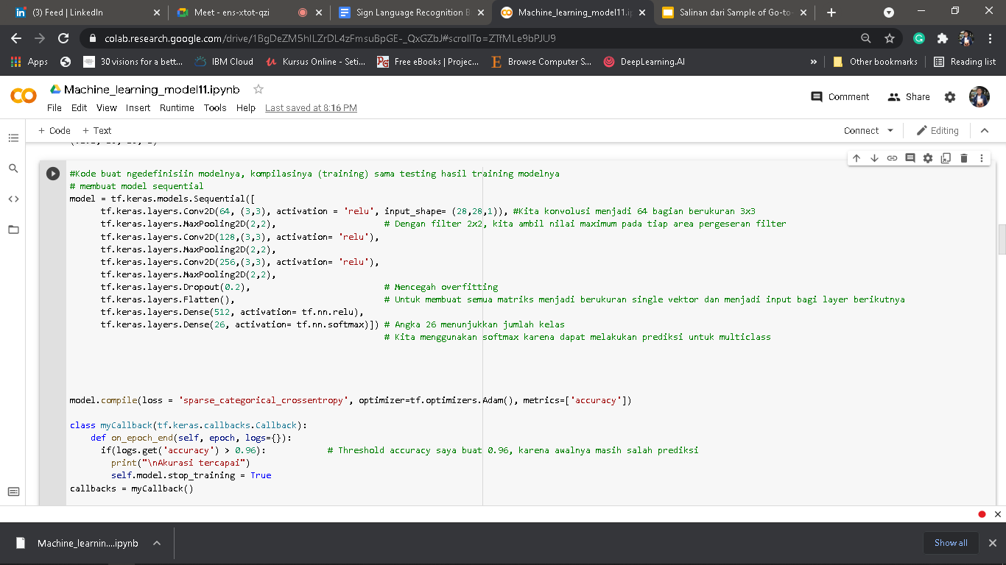

Machine Learning Model Training

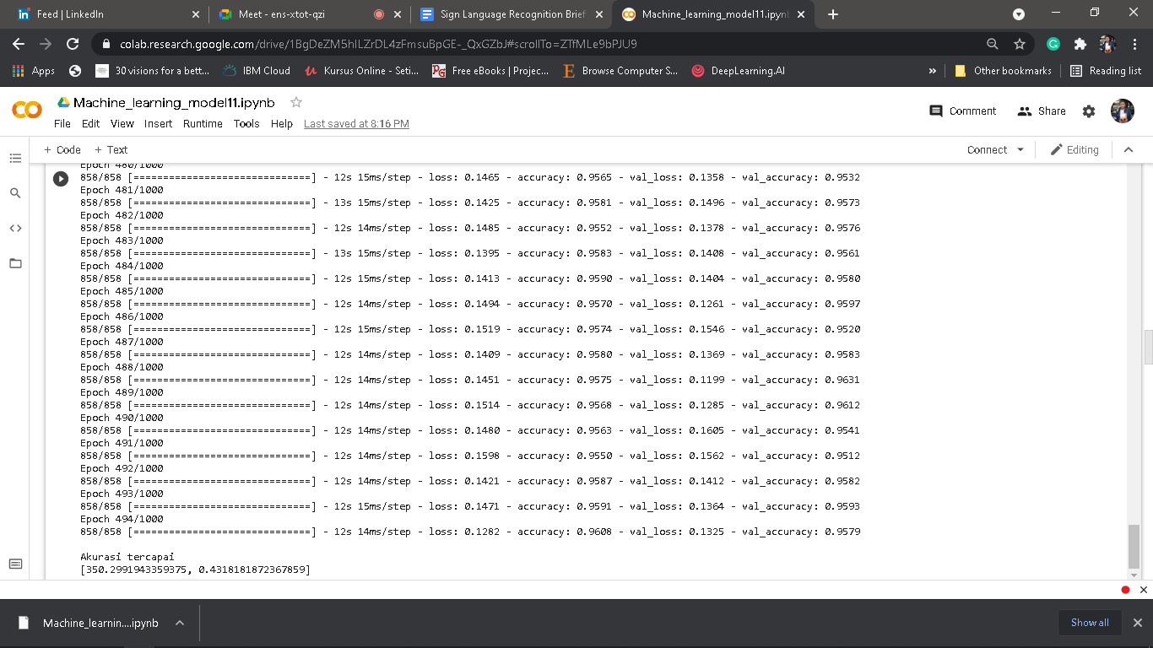

Machine Learning Model Summary

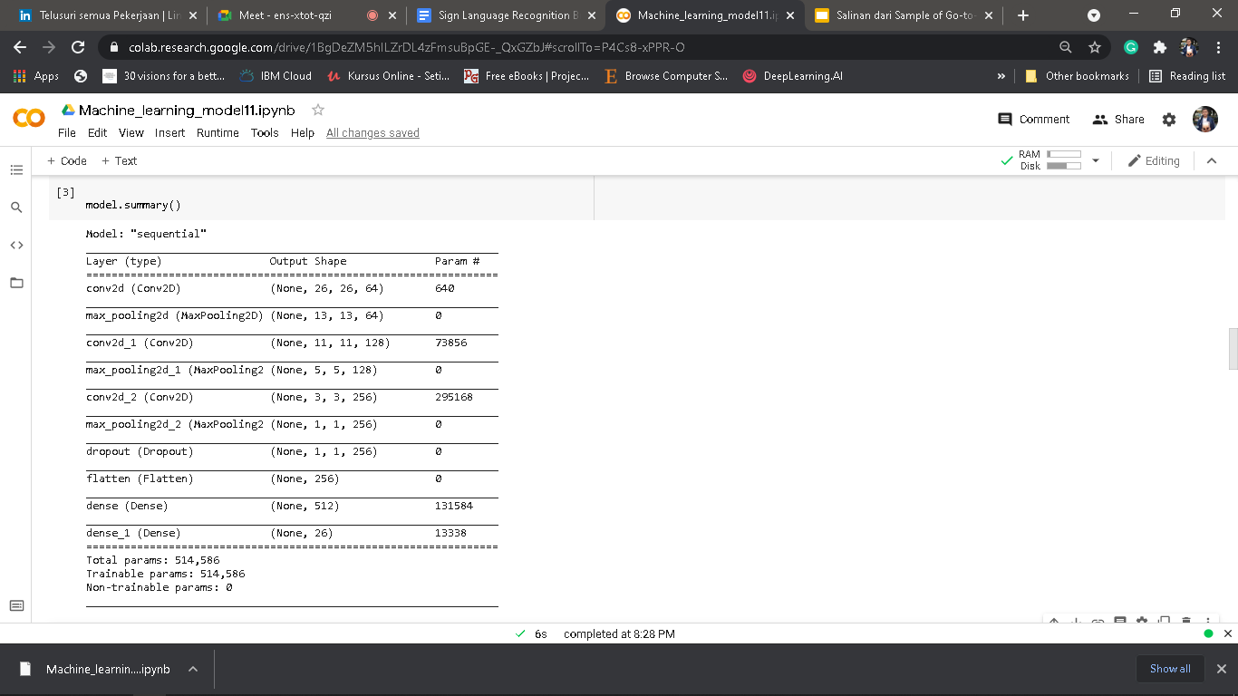

Machine Learning Training and Validation Accuracy

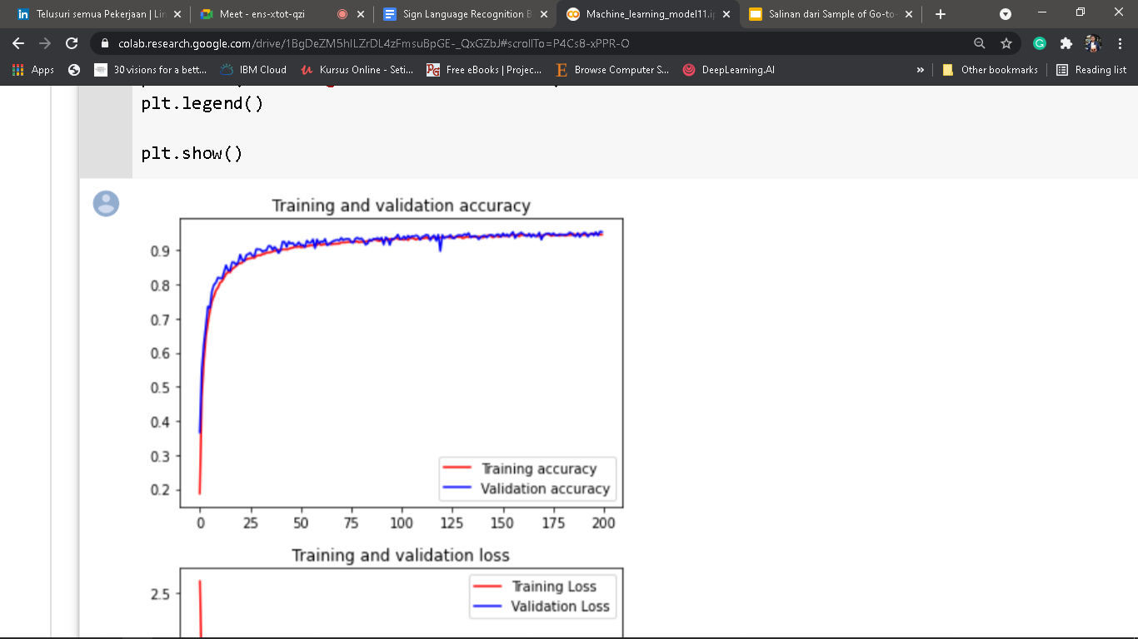

Machine Learning Training and Validation Loss

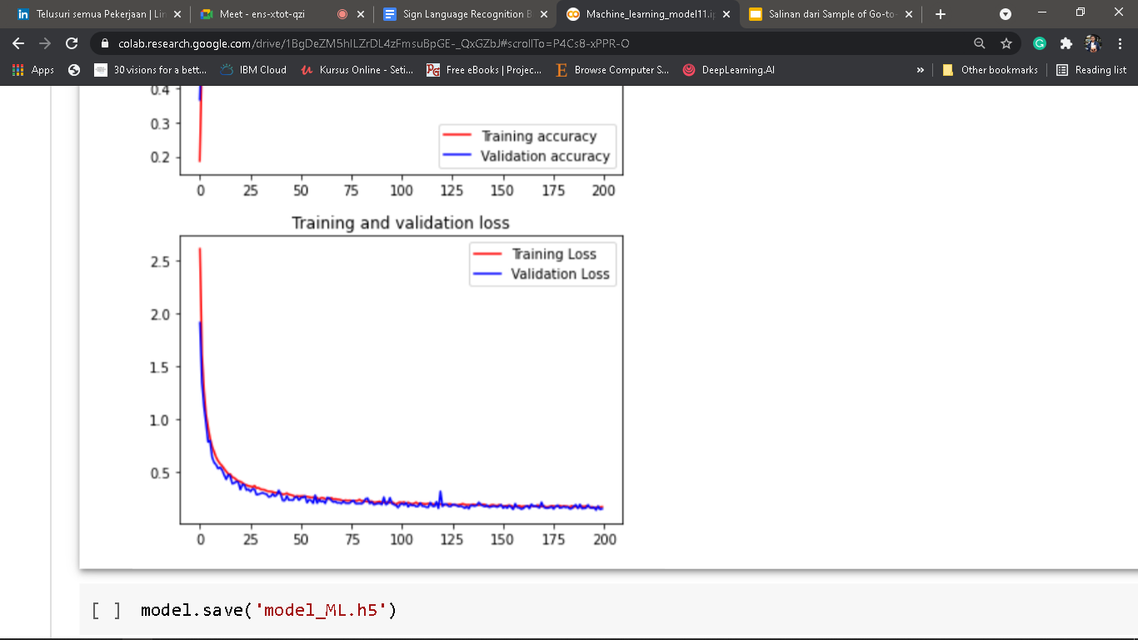

Cloud Function Logs

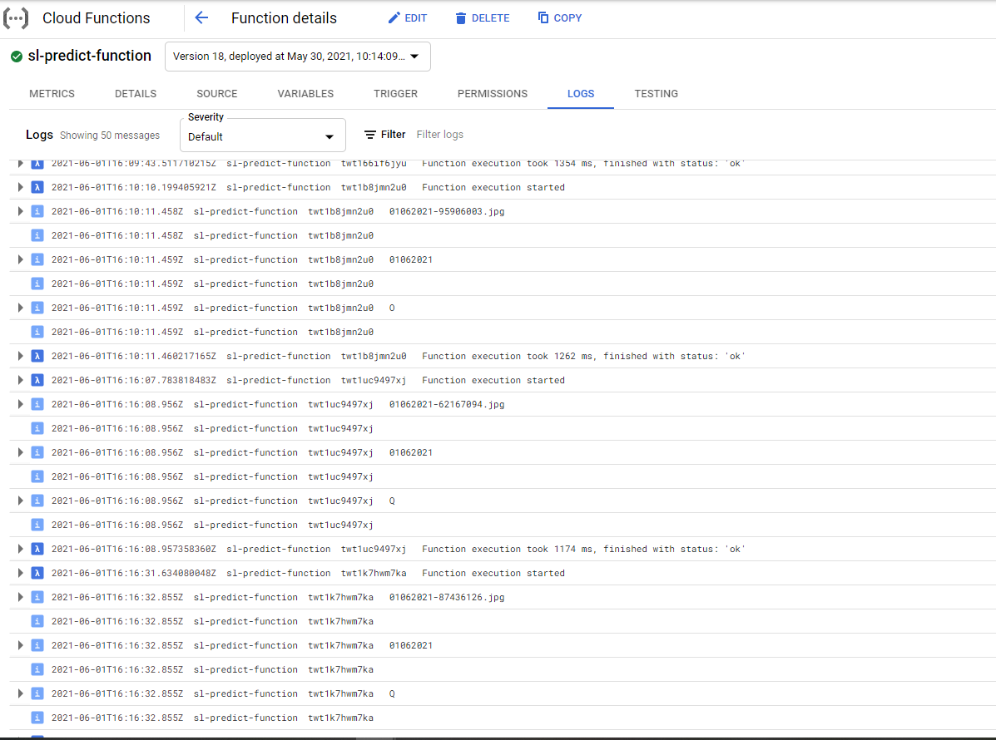

#### **Dataset Link**:

Open source dataset for training and validation: <https://www.kaggle.com/datamunge/sign-language-mnist>

#### **Deployed Link:**

Jupiter Notebook File for ML Model: <https://github.com/envyst/sign-language-application/blob/master/machine-learning-file/Machine_learning_model11.ipynb>

Android Apk File:

<https://github.com/envyst/sign-language-application/blob/master/sign-language-app.apk>

#### **Github Repo Link:**

Github repository link for cloud, ML and android source-code:

<https://github.com/envyst/sign-language-application>

#### **Academic Paper Link:**

[1] Penerjemahan Bahasa Isyarat Indonesia Menggunakan Kamera pada Telepon Genggam Android -<https://media.neliti.com/media/publications/193113-ID-penerjemahan-bahasa-isyarat-indonesia-me.pdf>

[2] AI and Machine Learning for Coders: A Programmer’s Guide to Artificial Intelligence

[3] Implementation of CameraX on Android App - <https://developer.android.com/codelabs/camerax-getting-started>

[4] Tensorflow documentation - <https://www.tensorflow.org/api_docs>

[5] Machine Learning Model as a Serverless Endpoint using Google Cloud Function - <https://towardsdatascience.com/machine-learning-model-as-a-serverless-endpoint-using-google-cloud-function-a5ad1080a59e>

#### **10-Min Video Presentation Link:**

https://youtu.be/Lii0cWr6jYE

#### **Slide Presentation Link:**

https://docs.google.com/presentation/d/1QOoIPRrP3nbvF2en9PdtbI3I7LEOYL9DNY818tlLDqE/edit?usp=sharing